**e – Recruitment Management System (e-RMS)**

**INTRODUCTION AND OBJECTIVES OF THE PROJECT**

The recruitment process in India is an ongoing activity, with vacancies in various government departments being filled annually. Managing the applications of millions of candidates who participate in these recruitment drives is a massive undertaking.

As of 2024, despite the overwhelming interest in these jobs, with over 20 million applicants participating in competitive examinations each year, there are around 9.79 lakh vacancies in various central government departments. This includes positions across ministries and public sector undertakings. For instance, approximately 16,719 non-teaching and 5,060 teaching posts remain unfilled in central universities alone. The same is also true for the State Governments. This imbalance underscores significant inefficiencies in the recruitment and appointment processes, leading to unutilized opportunities for both job seekers and government institutions​

Many government institutions continue to rely on traditional methods for handling recruitment notices physically. While some have transitioned to a semi-digital application process, tasks such as processing results and issuing appointment letters are still carried out manually.

The physical processing of applications leads to challenges and losses for all parties involved. For instance, once a provisional appointment letter is issued, it typically takes 10-15 days to reach the recipient. In some cases, the letter may be lost in transit, potentially resulting in the cancellation of the appointment.

India has a significant unemployed population actively seeking job opportunities, yet many positions in government agencies remain unfilled. This issue arises partly due to the lack of a structured waiting list for qualified candidates who missed appointments due to intense competition. The offline recruitment management system further exacerbates the problem by lacking the efficiency and transparency needed to address such gaps effectively.

The e-Recruitment Management System aims to address the limitations of the traditional, physical recruitment process. It will feature modules for receiving applications, processing results, and automating the allotment of vacancies based on the specific criteria outlined in each recruitment notice.

The e-Recruitment Management System benefits both key stakeholders in the recruitment process: the appointee and the appointer. Candidates can register on the system to view all open recruitment notices and apply directly. Recruiters, on the other hand, can create recruitment notices, enter candidates' results, and let the system automatically sort and generate a rank list. Once the rank list is prepared, recruiters can send appointment letters to selected candidates. Candidates can then accept or reject the offer through the system. If an offer is rejected, the recruiter can seamlessly issue an appointment letter to the next eligible candidate on the rank list.

This system aims to streamline the recruitment process, significantly reducing delays and inefficiencies. By addressing the issue of repeated vacancies in certain offices, it enhances the effectiveness of the recruitment cycle. Additionally, the system promotes the judicious use of resources while improving operational efficiency and ensuring greater transparency in the hiring process.

**PROJECT CATEGORY**

Applications, RDBMS, Internet Technologies, Web-Development

**ANALYSIS**

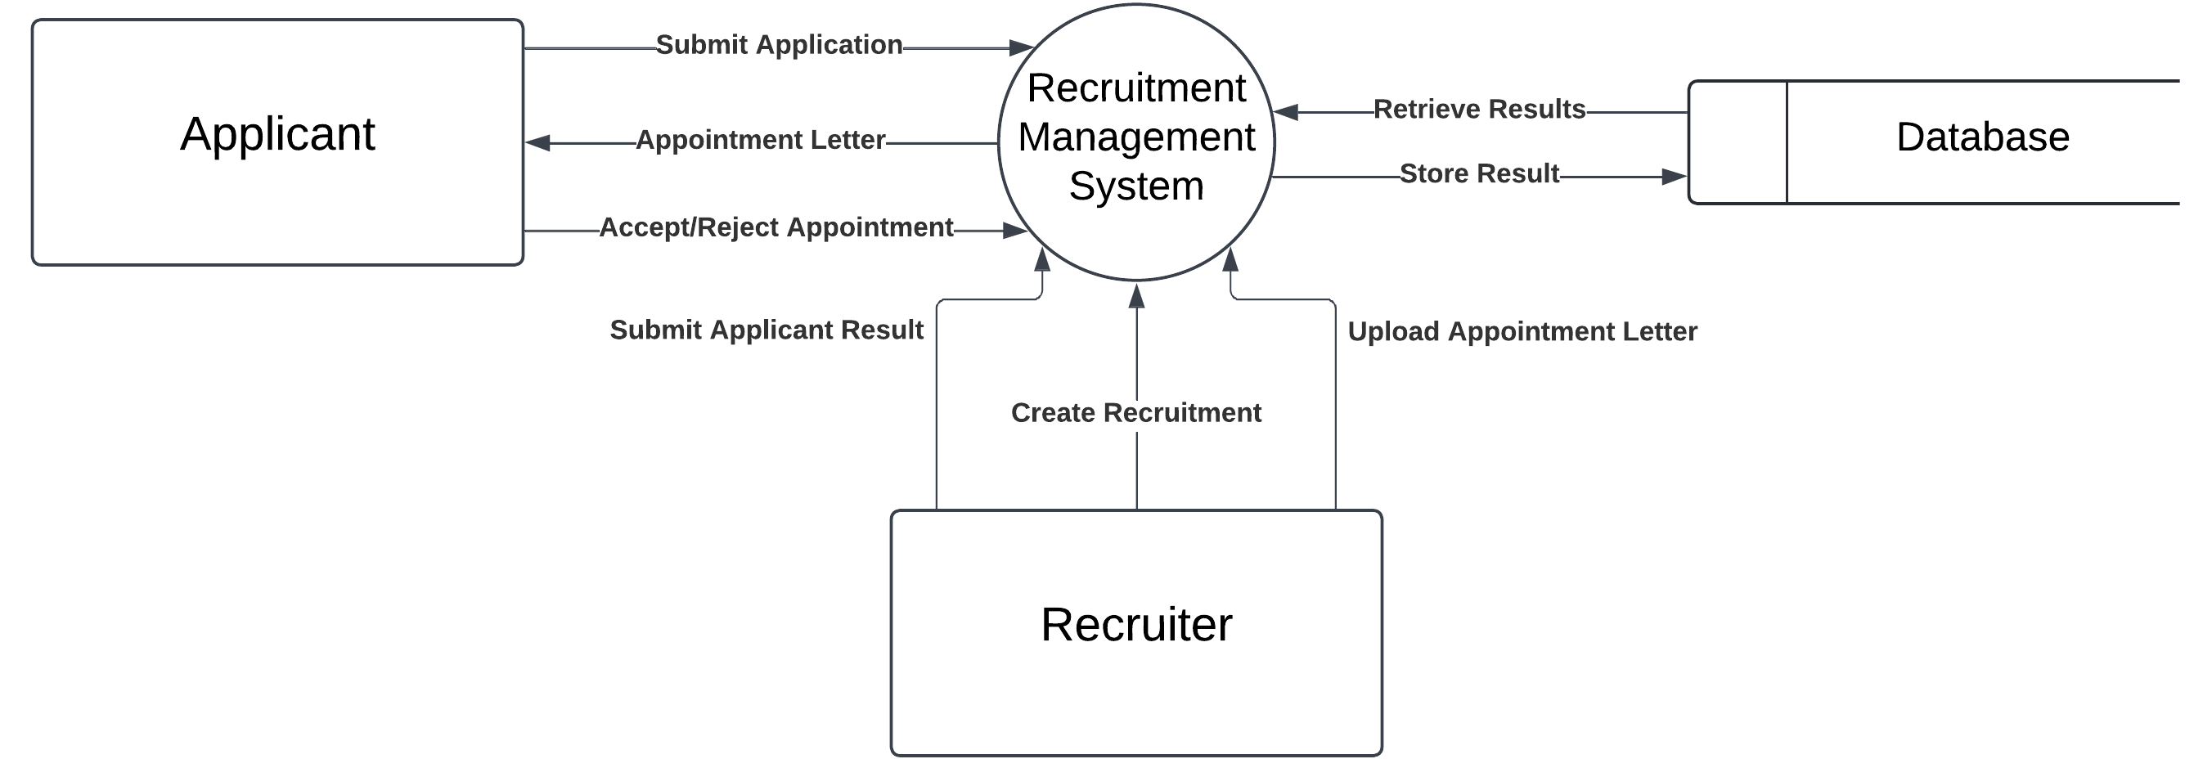**1. DATA FLOW DIAGRAM**

**Level 0 Data Flow Diagram – e-RMS**

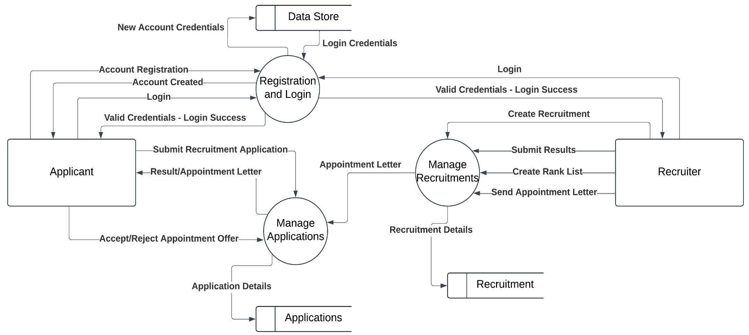

**Level 1 Data Flow Diagram – e-RMS**

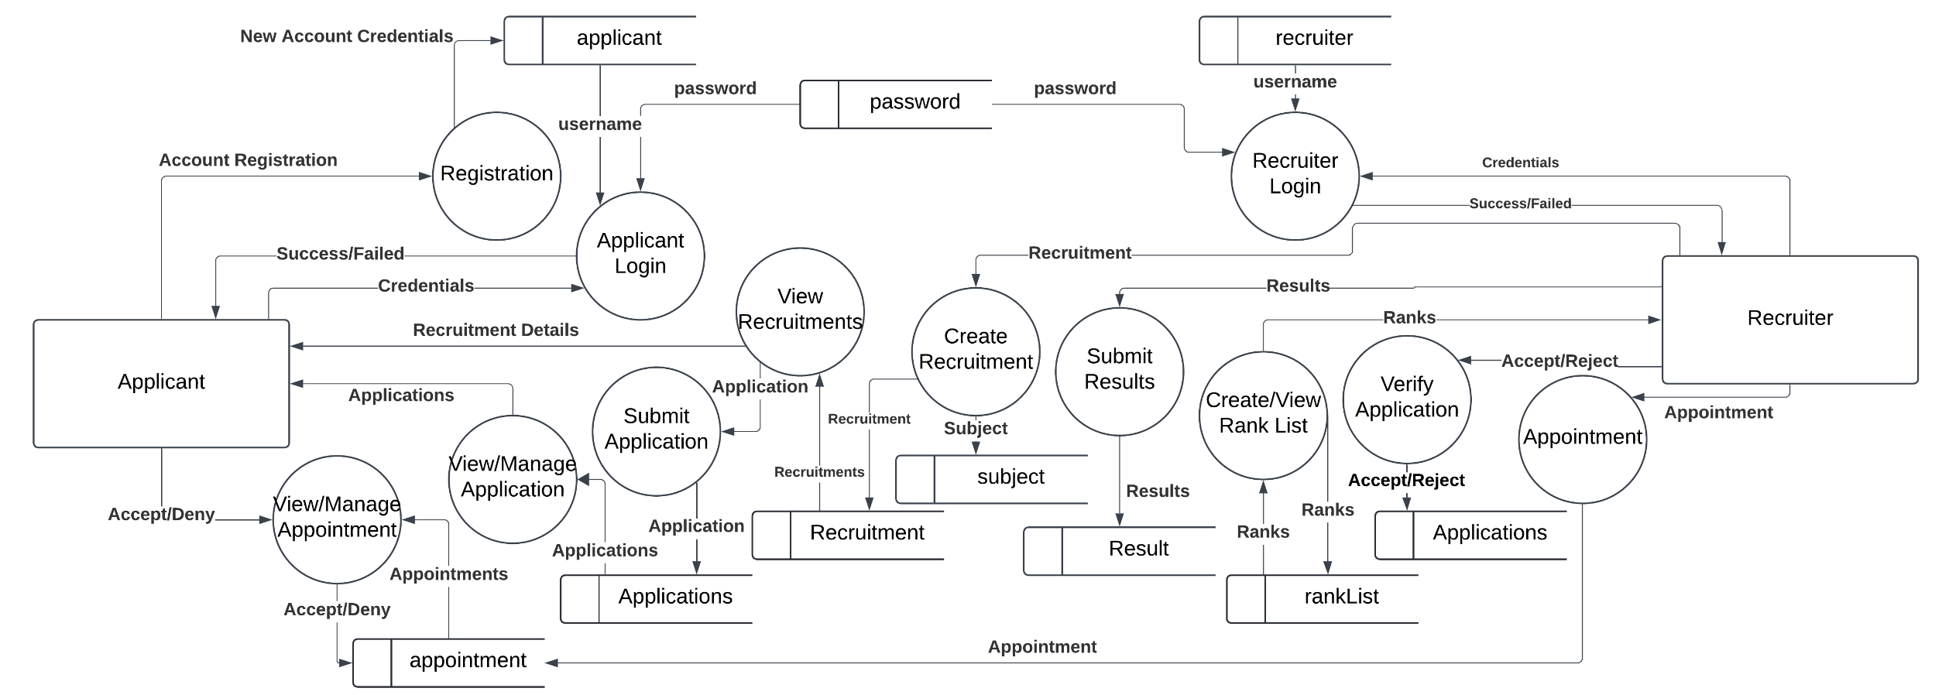

**Level 2 Data Flow Diagram – e-RMS**

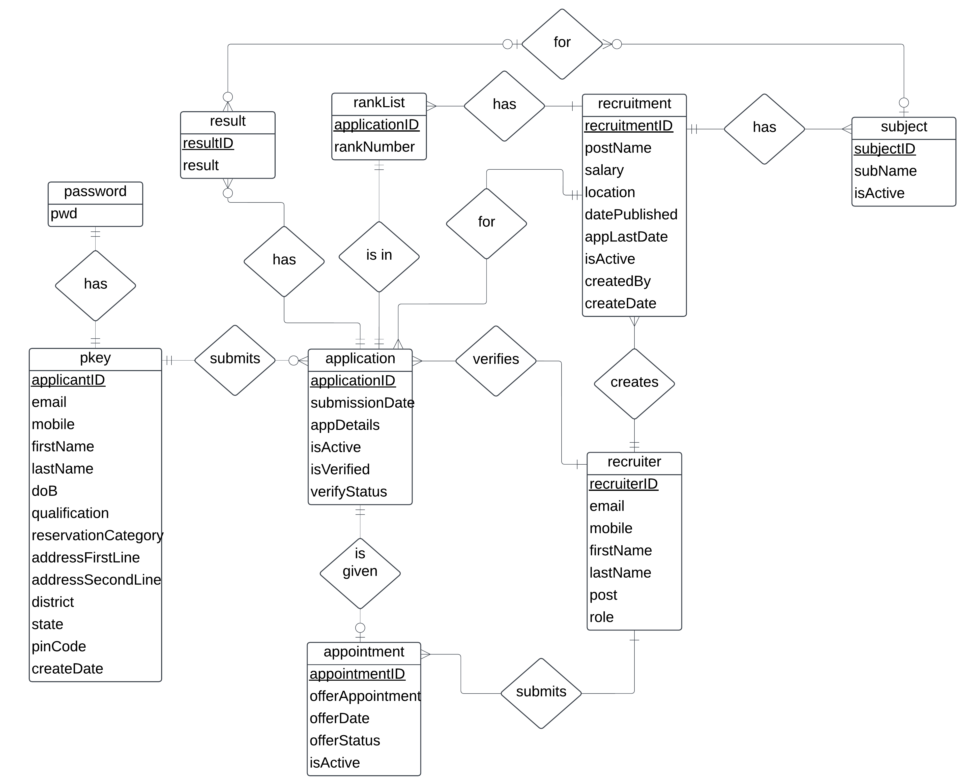**2. ENTITY-RELATIONSHIP DIAGRAM**

**Entity-Relationship Diagram – e-RMS**

**3. DATABASE DESIGN**

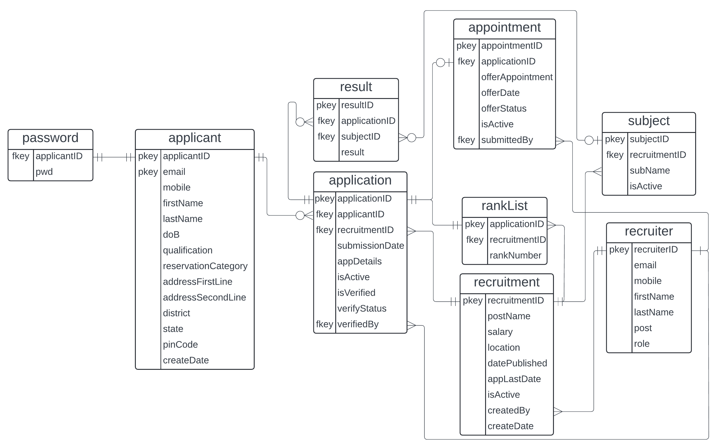

**Database Design – e-RMS**

**MODULES**

There are a total of 12 modules in the system. These modules are divided into two segments:

1. Applicant Side
2. Recruiter Side

1. Applicant Side

1. Registration: This is the first module that the applicant interacts with. Applicants register on the system using this module by submitting a form. The input is saved in the database, which creates an account for the candidate.

Process Logic:

START

READ registration_input

IF registration_input in VALID FORMAT THEN

RETRIEVE stored_username FROM database

IF username IN registration_input != stored_username

STORE registration_input IN database

DISPLAY “Account Creation Successful” message

GO TO LoginProcess

ELSE

DISPLAY “Username already exists” error message

END IF

ELSE

DISPLAY “Invalid Format” error message

END IF

END

1. Applicant Login: This module serves the login function for applicants. It will take user credentials as input and verify them from the database. If the credentials match, the applicant will be directed to the next module. If they do not match, the module will give a “username does not exist” or “incorrect password” prompt.

Process Logic:

START

READ username, password

RETRIEVE stored_password FROM database USING username

IF stored_password is NOT FOUND THEN

DISPLAY “Username does not exist” error message

ELSE

IF password != stored_password

DISPLAY “Incorrect Password” error message

ELSE

GO TO ViewRecruitmentProcess

END IF

END IF

END

1. View Recruitments: Applicants can view the various recruitment notices through this module.

Process Logic:

START

RETRIEVE stored_recruitment FROM database

FOR EACH stored_recruitment IN stored_recruitments_details

DISPLAY stored_recruitment_detail

END FOR

ON INPUT submitButtonClicked

GO TO SubmitApplicationProcess

END ON

END

1. Submit Application: The applicant will submit the application for their desired recruitment through this module. Required details for the recruitment will be taken using a form and will be submitted to the database. This will create an application.

Process Logic:

START

READ application_details

IF application_details in VALID FORMAT

STORE application_details IN database

DISPLAY “Application Submitted” message

ELSE

DISPLAY “Invalid Format” error message

END IF

END

1. View/Manage Application: The module will allow applicants to manage the applications made by them and view or cancel the application.

Process Logic:

START

RETRIEVE applications FROM database

FOR EACH application IN applications

DISPLAY application

END FOR

ON INPUT cancelApplicationButtonClicked

CANCEL application

END ON

END

1. View/Manage Appointment: An offer of appointment, if sent to an applicant by a recruiter, will be available in this module. The applicants can accept or deny the offer through this module.

START

RETRIEVE appointments

FOR EACH appointment IN appointments

DISPLAY appointment

END FOR

ON INPUT acceptButtonPressed

UPDATE offer_status = accepted IN database USING appointment_id

END ON

ON INPUT rejectButtonPressed

UPDATE offer_status = rejected IN database USING appointment_id

END ON

2. Recruiter Side

1. Recruiter Login: This module serves the login function for the recruiters. It works the same way as the Applicant Login module except the credentials are stored in a different table than the applicants.

Process Logic:

START

READ registration_input

IF registration_input in VALID FORMAT THEN

RETRIEVE stored_username FROM database

IF username IN registration_input != stored_username

STORE registration_input IN database

DISPLAY “Account Creation Successful” message

GO TO LoginProcess

ELSE

DISPLAY “Username already exists” error message

END IF

ELSE

DISPLAY “Invalid Format” error message

END IF

END

1. Create Recruitment: Recruiters can create a recruitment notice using this module. The various details of the recruitment notice for example, Salary, Job location etc. will be taken through a form and stored in the database.

Process Logic:

START

READ recruitment_input

SAVE recruitment_input IN database

DISPLAY “Recruitment Created” message

END

1. Submit Results: The results of the candidates will be stored through this module. The recruiter will fill the results on a form, which will be created dynamically as per the requirements of the recruitment. The subject wise result shall be stored in the database on submitting the form.

Process Logic:

START

RETRIEVE applications FROM database

READ results

ON INPUT saveResultButtonClicked

FOR EACH result IN results

IF result_applicant_id == stored_application_id

SAVE result IN database

ELSE

DISPLAY “Applicant ID not found” error message

END IF

END FOR

END ON

END

1. Create/View Rank List: Once the submission of the results of all candidates is complete, the module will compare the results of all the candidates and create a rank list. The offer of appointments will be sent to the candidates as per the rank list.

Process Logic:

START

RETRIEVE applications, results FROM database

ON INPUT createRankListButtonClicked

FOR EACH application IN applications

IF result NOT FOUND

DISPLAY “Results of some applicants are not yet updated. Are you sure you want to create the Rank List?” message

READ buttonClicked

IF buttonClicked == no

EXIT

END IF

END IF

END FOR

ORDER results BY descending order of marks

FOR EACH result in results

SAVE rank IN database

END FOR

RETRIEVE ranks FROM database

DISPLAY ranks

END

1. Verify Application: The verify application module will allow the recruiters to review the application details of the candidates and approve/reject them.

START

RETRIEVE applications FROM database

DISPLAY applications

ON INPUT verifyButtonClicked

UPDATE application_status = verified IN database

END ON

ON INPUT rejectButtonClicked

UPDATE application_status = rejected IN database

END ON

END

1. Appointment: Recruiters can use this module to submit an offer of appointment to the candidates. They can also manage the appointments using this module.

Process Logic:

START

RETRIEVE applications FROM database WHERE application_id IS FOUND in rank_list

DISPLAY applications

READ appointment_input

ON INPUT sendAppointmentButtonClicked

SAVE appointment_input IN database

END ON

END

**TESTING**

Testing is a critical aspect of software development that demands careful attention. It ensures the system is functional and user-friendly while identifying issues ranging from minor design flaws, such as incorrect color schemes, to significant errors that could lead to a total system breakdown.

As e-RMS is a web application, the tests are designed in accordance with standard web application testing practices. To ensure the quality of e-RMS, the following tests will be conducted:

1. Functional Testing: Functional Testing focuses on evaluating the overall functionality and operational capabilities of a web application. It involves testing all features and behaviors to verify their compatibility with the specified requirements. This type of testing does not delve into the internal workings of the application but instead ensures that outputs align with the expected results for given inputs. Functional Testing for the e-RMS will validate the functionality and accuracy of outputs across all system modules.
2. Usability Testing: Usability testing evaluates the user-friendliness of a web application's elements. It assesses the application's flow and ensures smooth navigation for users. This testing is conducted from the perspective of end-users, making it crucial to understand user preferences and their specific needs. e-RMS will serve millions of users, making accessibility a top priority. To ensure this, usability testing will be carried out.
3. Database Testing: Database testing is essential to ensure the web application efficiently stores and manages data. It involves executing queries to identify errors, monitoring query response times, verifying the accurate reflection of retrieved test data in the application, and ensuring that any changes made during data creation, updating, or deletion maintain data integrity. e-RMS heavily depends on its database to store, process, and finalize applicant results. Database testing will ensure its seamless and reliable functionality.
4. Performance Testing: Performance Testing evaluates a system's speed, stability, and scalability across various scenarios, ensuring consistent efficiency under diverse user interactions. It verifies that the architecture can handle heavy load conditions, maintains fast response times with each software update, and delivers optimal performance even at maximum load capacity. The current solution, designed solely for receiving recruitment applications, frequently experiences server crashes due to the high volume of concurrent users. Therefore, performance testing is essential for the e-RMS to ensure it delivers optimal performance under such conditions.
5. Compatibility Testing: Websites can render differently across various browsers and their versions, making it essential to perform cross-browser compatibility tests. Cross-browser testing ensures that the web application functions seamlessly and consistently across multiple browsers on different desktop and mobile devices.
6. Security Testing: The process involves testing, analyzing, and reporting on all security aspects of an application to assess its vulnerability to potential threats. The goal is to ensure the app's resilience against security breaches, protecting user data and maintaining system integrity. Since the e-RMS will handle data that impacts individuals' futures, it is crucial to ensure that it remains secure and free from any vulnerabilities.

The tests outlined above will be carried out using a combination of manual and automated testing, depending on the specific requirements of each test. It is to be noted that the testing details are still being determined and may change based on the system's requirements.

**REPORT GENERATION**

The system will provide access to various reports, including:

1. Applicant Registration: This report will provide insights into the number of applicant registrations for the year, along with a breakdown of applicants into various categories, such as age group, scheduled category, and more.
2. Recruitment Applications: The total number of applications received for a recruitment drive along with a state-wise breakdown.
3. Appointments Report: Recruitment-wise data on the number of appointments sent, along with the counts of accepted, rejected, and appointments canceled due to the expiration of the deadline.

**TOOLS**

The e-RMS is a web-based application that will be developed using the following languages:

1. HTML, CSS, Javascript (Front-end) (ReactJS may also be included later)
2. PHP (Back-end)
3. MySQL (DBMS)
4. Python & Selenium (Testing Automation)

Hardware:

* + - 1. User: Any device which supports a browser
      2. Administrator: The e-Recruitment Management System (e-RMS) must handle millions of user applications, necessitating a robust, large-scale enterprise-grade system for hosting. During development, Amazon Web Services (AWS) will be used.

**FUTURE SCOPE OF THE PROJECT**

1. The current system is designed with two primary parties in mind: recruitees and recruiters. A third party, the "Recruitment Agency," is being considered to streamline the recruitment process for users who rely on such agencies, such as the Staff Selection Commission (SSC).

2. Include a "Compile Vacancy" module to enable the direct compilation of vacancies from multiple offices within the system.

3. Add support for multiple office locations for recruiters and location preferences for applicants. Update the "Send Appointment Module" to incorporate these location preferences alongside applicant ranks, ensuring eligible candidates are presented to recruiters accordingly.

**IS THIS PROJECT FOR ANY INDUSTRY/CLIENT: NO**